What Employers Need to Know: 5 Essential Elements for Fair Hiring
Hiring new employees is a critically important function in any business, government agency, or non-profit organization. Every hiring decision represents a major investment that employers must make with limited information. Checking criminal history is just a small part of this process, which may also include verifying education, prior employment and other reference information. There are five essential elements of the Best Practice Standards that ensures an employer implements a fair hiring policy that gives every candidate a fair opportunity to compete for work.

(1) Know What Convictions Are Relevant to Risks of Harm in the Job

Setting
» ConsiderOnlyConvictionsThatAreRelevanttotheJobinQuestion.The employer should identify the types of risks presented by the job situation and screen for convictions associated with those risks (e.g., screening CFOs for embezzlement or other theft convictions, drivers for DUIs).
» ConsiderOnlyConvictionsRecentEnoughtoIndicatePresentRisk.Employers should set a cut-off time that reflects available evidence; many studies find the risk of repeat offending is negligible after 3, 5, or 7 years.

(2) Ask About Qualifications First
» DoNotAskAboutCriminalRecordsonInitialApplicationForms–AskLater.Obtain information on the qualifications rather than automatically excluding a potentially valuable candidate based on assumptions or stereotypes about character.

(3) Use Reliable Methods to Perform Background Checks – Don’t Just

Seek Low Cost
» EngageaQualifiedConsumerReportingAgency(CRA)ThatWillKnowtheLawand ReporttotheEmployer:
- Only convictions that are relevant and recent
- Only when full name and another identifier match the candidate
- Information from online databases confirmed with original source
- Current disposition of information confirmed from official source
- All charges related to a single incident shown as a single entry
» AlwaysProvidetheApplicanttheOpportunitytoChallengetheCRA’sReportBeforea DecisionIsMade.

(4) Consider All Evidence Relevant to an Individual Applicant’s

Rehabilitation
» ConsiderAllEvidenceofRehabilitation. People change and become good citizens and good employees. An applicant, even with relevant convictions recent enough to be of concern, should not automatically be rejected. Instead, he or she should be given the opportunity to present evidence of rehabilitation – experience performing a similar job successfully, completion of training programs or educational advancement – that signal rehabilitation efforts the employer should carefully consider before making a decision.
(5) Design the Hiring Process to Implement Best Practices

Effectively
» TrainHumanResourcesStaff.Hiring managers should know federal and state law and the practical steps in determining if and how a criminal history may be relevant. HR employees who manage background screening should be thoroughly trained and regularly updated on relevant federal, state and local laws and in how to apply elements 1 – 4 in hiring of all candidates.
» MinimizeConflictofInterestbyDecisionMakers.Hiring decisions should be assigned to managers who can make informed and thorough assessments of candidates, while limiting the employer’s exposure to unreasonable risk. The employer’s diversity policy should effectively communicate the company’s commitment to equal opportunity and fair hiring for all qualified candidates, even those who may have past justice-involvement.

Best Practice Standards for Use of Criminal Records in Employment
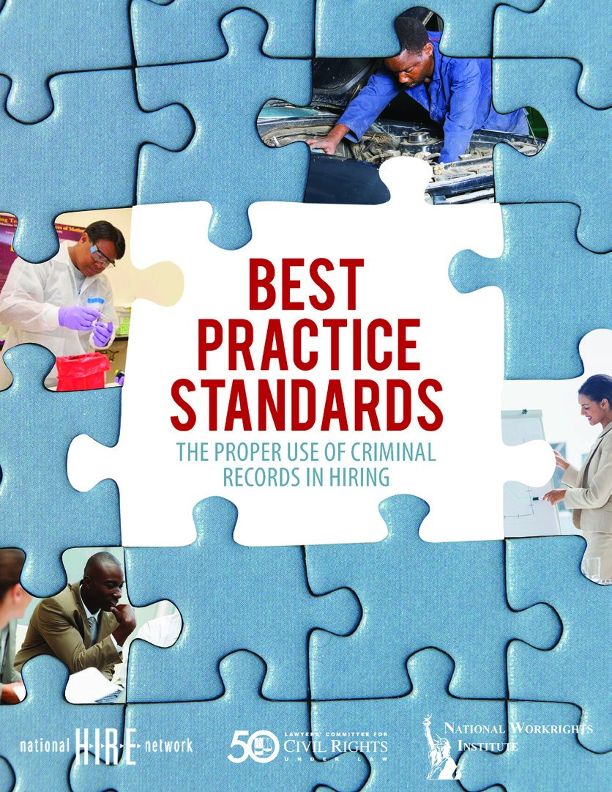
The report, Best Practice Standards: The Proper Use of Criminal Records in Hiring provides employers a guide to complying with the complex and competing requirements of Title VII of the Civil Rights Act of 1964, the Fair Credit Reporting Act, and avoiding liability for negligent hiring. The Best Practice Standards also help employers make informed decisions when dealing with applicants with criminal records. Find this report online at BestPracticeStandards.lawyerscommittee.org. Direct inquiries to lacinfo@lac.org or info_bestpractices@lawyerscommittee.org.
CONTRIBUTORS – SPONSORING ORGANIZATION STAFF:
RobertaMeyershasservedasDirectoroftheLegalActionCenter’sNational
H.I.R.E.Networkproject since 2005. Prior to her appointment as director, she held policy and direct service positions at the Legal Action Center for nearly 15 years. She has worked with policy makers and advocates around the country to identify public policy priorities that directly affect employment opportunities for people with criminal records and helped develop appropriate strategies to strengthen existing legislation or create model policies in individual states. She has authored guidebooks and policy briefs on criminal record policies that impact employment and has been called to testify before Congress, federal administrative agencies, and state legislators.
RayP.McClainhasservedasDirectoroftheEmploymentDiscriminationProject fortheLawyers’CommitteeforCivilRightsUnderLaw since 2010. In that position he leads the Committee’s efforts to combat employment discrimination through litigation, public education and policy advocacy. For over 30 years prior to joining the Lawyers’ Committee, he practiced law in South Carolina in the areas of civil rights, employment and labor law. He was certified as a specialist in Employment and Labor Law in South Carolina for 20 years.
LewisMaltbyispresidentoftheNationalWorkrightsInstitute. He has testified before Congress on the use of criminal records in employment and served on advisory taskforces to the United States Department of Justice and SEARCH (the association of state criminal record repositories). Working in the private sector for a number of years, Mr. Maltby served as Executive Vice President/General Counsel of Drexelbrook Controls, Inc., where his responsibilities included Human Resources.
CONSULTANTS FROM THE BACKGROUND SCREENING INDUSTRY:

The consultants’ participation in the development of the Best Practice Standards reflects only the professional views of the consultants and their companies, not the views or endorsement of any association of which they are members or officers.
AttorneyLesterS.RosenisFounderandCEOofEmploymentScreening
Resources®(ESR) a nationwide background check company located in California.
He is the author of both “The Safe Hiring Manual – The Complete Guide to
Employment Screening Background Checks for Employers, Recruiters, and
Jobseekers,” a comprehensive book on employment screening, and “The Safe Hiring Audit” (2008). Mr. Rosen was the chair of the steering committee that founded the NAPBS®, a professional trade organization for the screening industry and served as one of the first co-chairs in 2004. He is a frequent presenter nationwide on safe hiring issues.
FrederickG.GilesisSeniorVicePresidentofCARCO’sResearchDivision. CARCO Group, Inc., is a nationwide background check company with offices located
throughout the United States. Mr. Giles has more than 30 years of experience in loss prevention, public record retrieval, employment screening, corporate asset protection, and investigations. He is a member of the Society for Human Resources Management and is also a founding member and former Chair of the Board of Directors of the National Association of Professional Background Screeners (NAPBS®). JamesC.OwensisChiefExecutiveOfficerandPresidentofCARCOGroup,Inc., both positions he has held since 2008. He has over 23 years of operations and information technology experience. He originally joined CARCO as the Chief Information and Technology Officer (CITO). As CITO and head of the background screening division, he led the modernization of CARCO’s technology and operations. Through that modernization CARCO implemented industry-leading approaches to the performance of high-volume background checks and enhanced the high quality level of CARCO’s services.



NatioNal Workrights iNstitute

